Worksheet 3.2

Isolation and new species
Answers
1. The following cartoon and statements summarise how isolation can lead to the formation of new species.
(a) Place the statements in the correct order in the flow chart using the letters A–G.
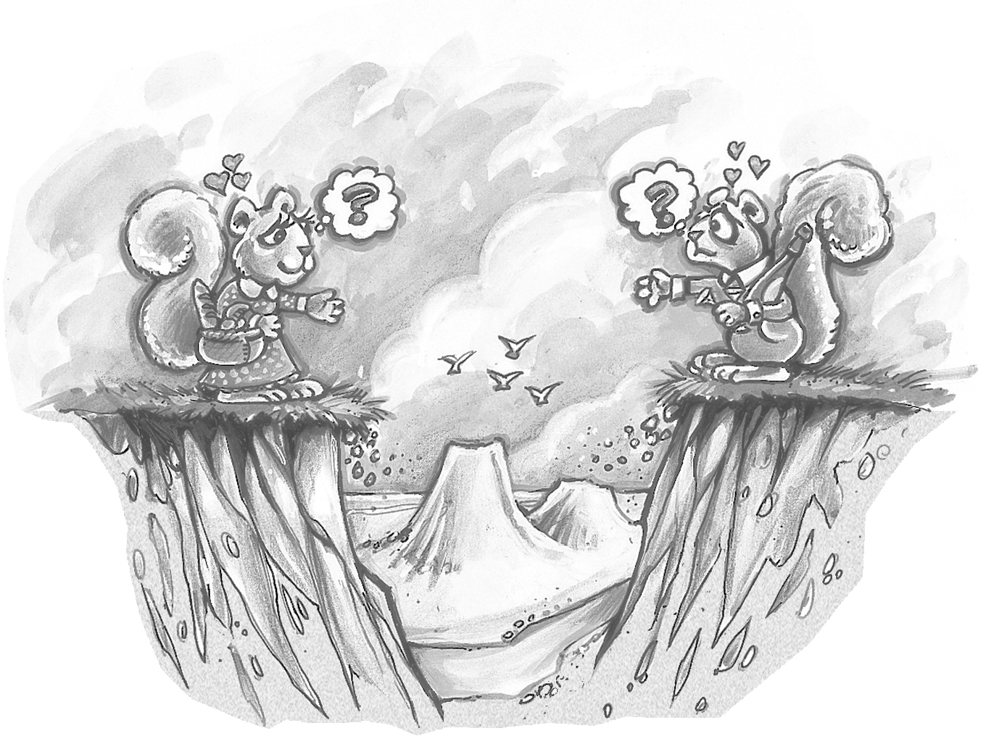
F
C
A
B
E
D
G

A | Survivors reproduce and pass on favourable genes and features to offspring. | B | The environment changes. Because of selection, some characteristics are favoured over others. Those best suited to the environment survive. | C | The frequency at which the genes for the new characteristics appear increases. | D | The breeding population becomes isolated.

 | E | Different characteristics arise through random genetic drift, mutation and environmental pressures. | F | The isolated population is now quite different, producing a new species. | G | Variation of characteristics is present in a population.
(b) Explain the meaning of the cartoon in relation to the formation of new species.
If two populations of animals of the same species become geographically isolated (e.g. separated by a deep valley or ocean), then these two populations will evolve separately and different selection pressures will operate in each environment. Along with differences in mutations, the two separate populations will become genetically different over time and new species will form.

Worksheet 3.2

Page 2

2. The Australian emu, the African ostrich and the kiwi in New Zealand are believed to have evolved from a common ancestor.
(a) Explain why it is possible for flightless birds in Australia, New Zealand and Africa to have a common ancestor even though these landmasses are now separated by oceans.
Australia, New Zealand and Africa were all part of Gondwana, so it would have been possible for the ancestor of the emu, ostrich and kiwi to have spread from one of these areas to another by walking.

(b) The emu and the kiwi are quite different birds. Explain how one species of flightless birds can evolve into a number of different species over time.
As Gondwana broke up into a number of landmasses, the organisms on each landmass became isolated from each other and the members of one species on one landmass could not interbreed with the members of the same species on a different landmass. For example, there would have been populations of the ancestor of today’s flightless birds on a number of the landmasses that made up Gondwana and these populations would have become isolated from each other. Each population was then exposed to different selection pressures as the environment on each landmass was different. This resulted in each population evolving in a particular direction. Over time, the populations became so different that they could no longer interbreed, having thus become new species.

